Google Maps API Issue
LOG Autocomplete API error: REQUEST_DENIED You’re calling a legacy API, which is not enabled for your project. To get newer features and more functionality, switch to the Places API (New) or Routes API. Learn more: https://developers.google.com/maps/legacy#LegacyApiNotActivatedMapError"

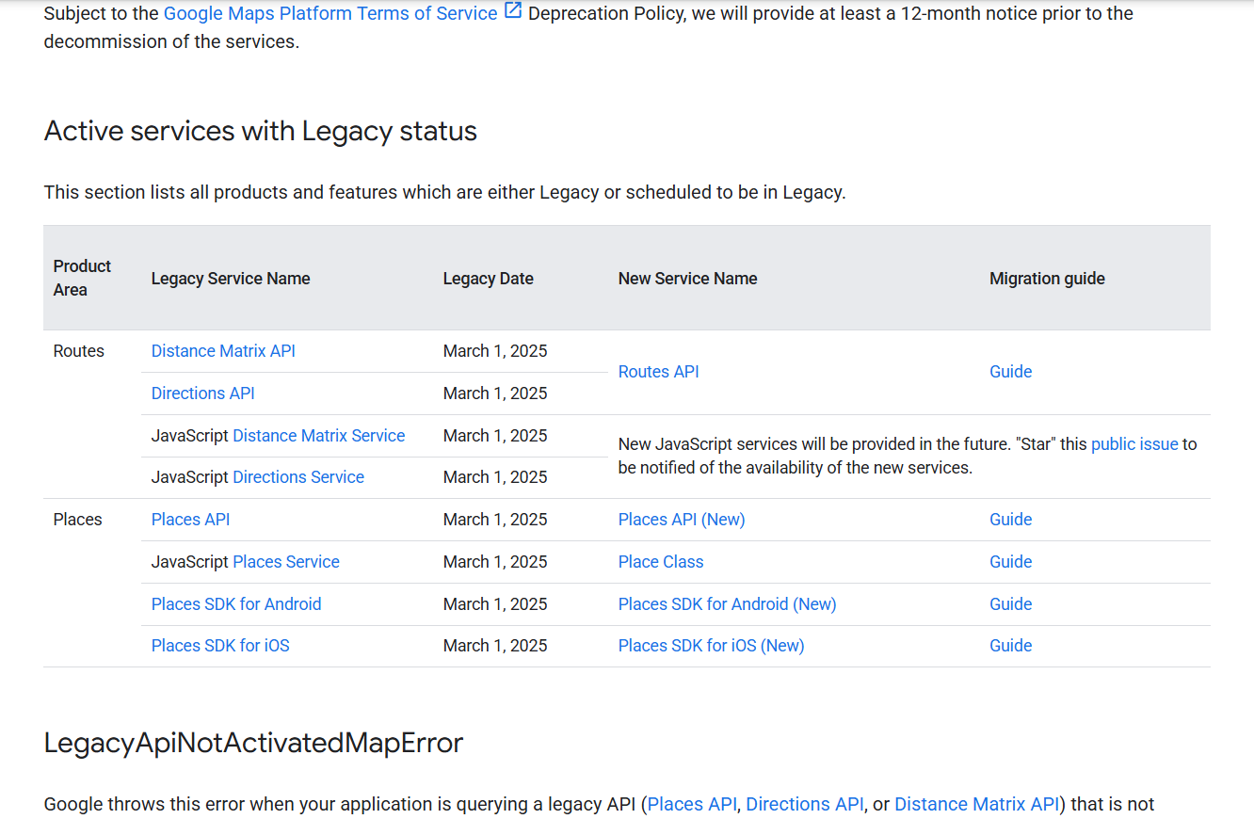
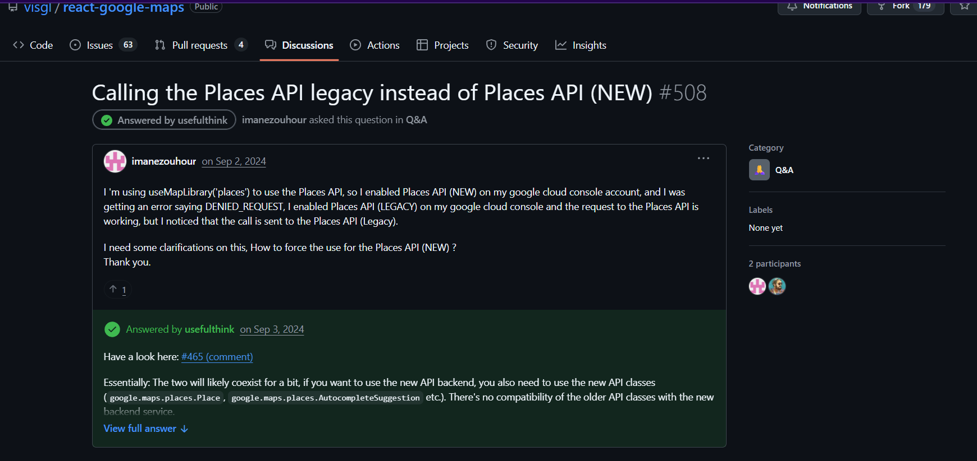
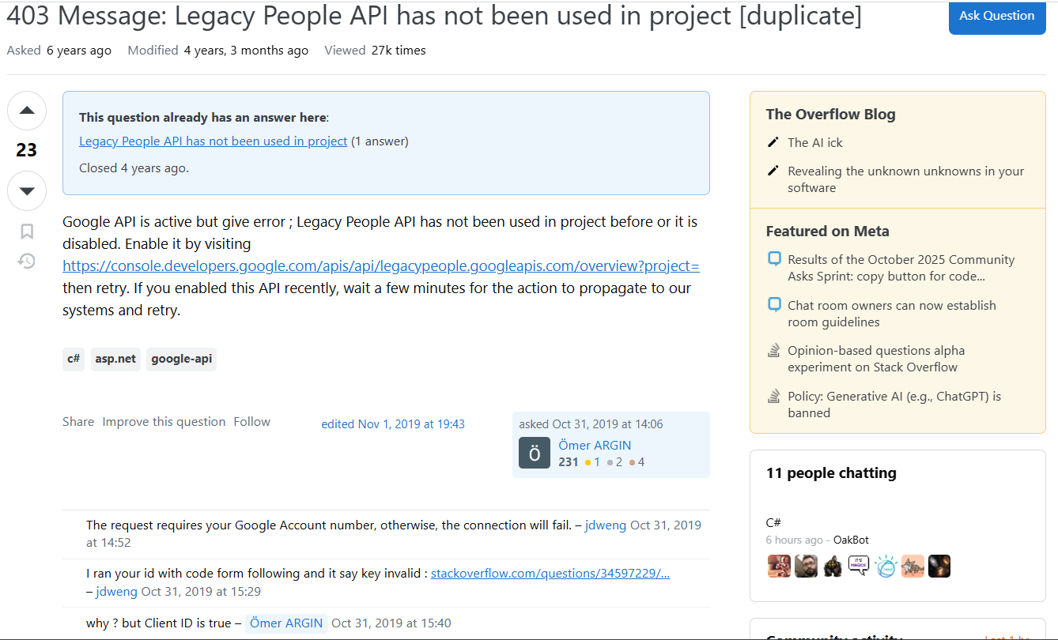

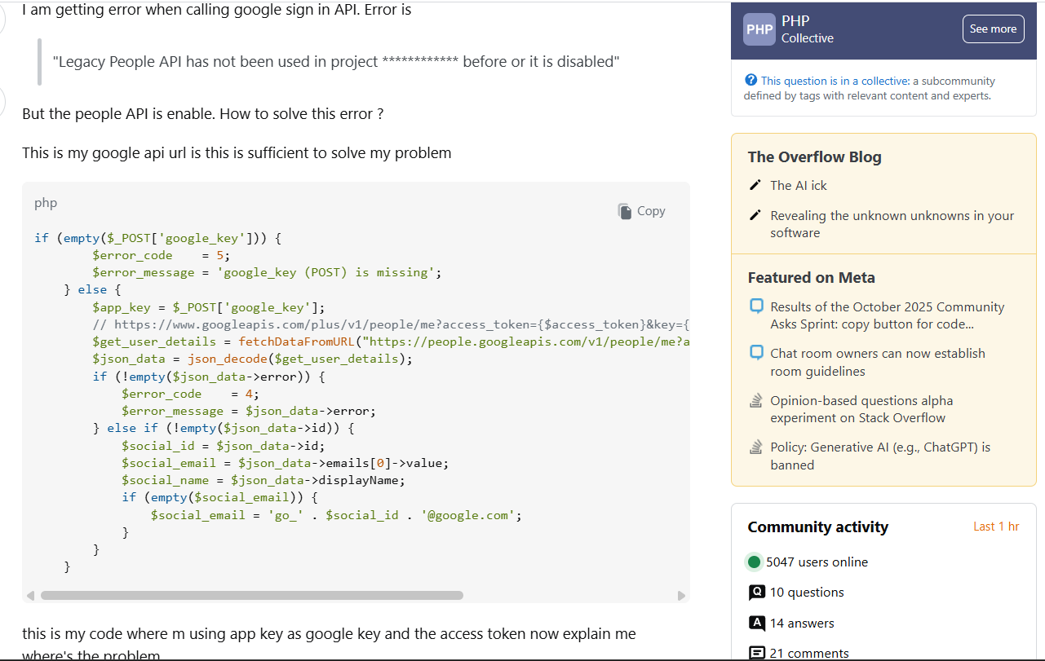
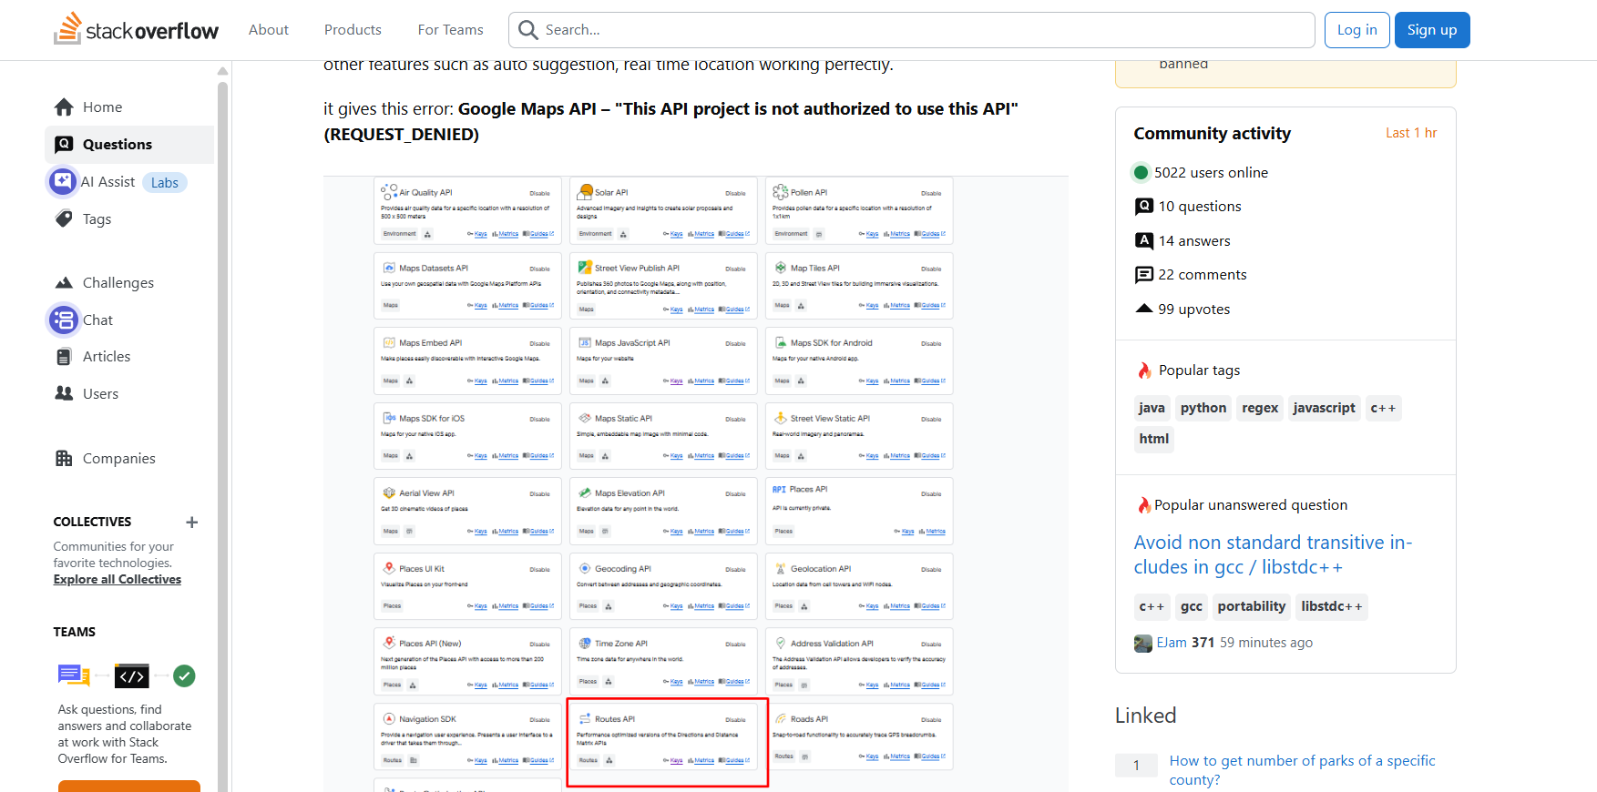
https://stackoverflow.com/questions/58645078/403-message-legacy-people-api-has-not-been-used-in-project

Some Youtube Videos watched to resolve the maps api issues:
https://www.youtube.com/watch?v=Zxf1mnP5zcw
https://www.youtube.com/watch?v=PgJN4sPL1bQ
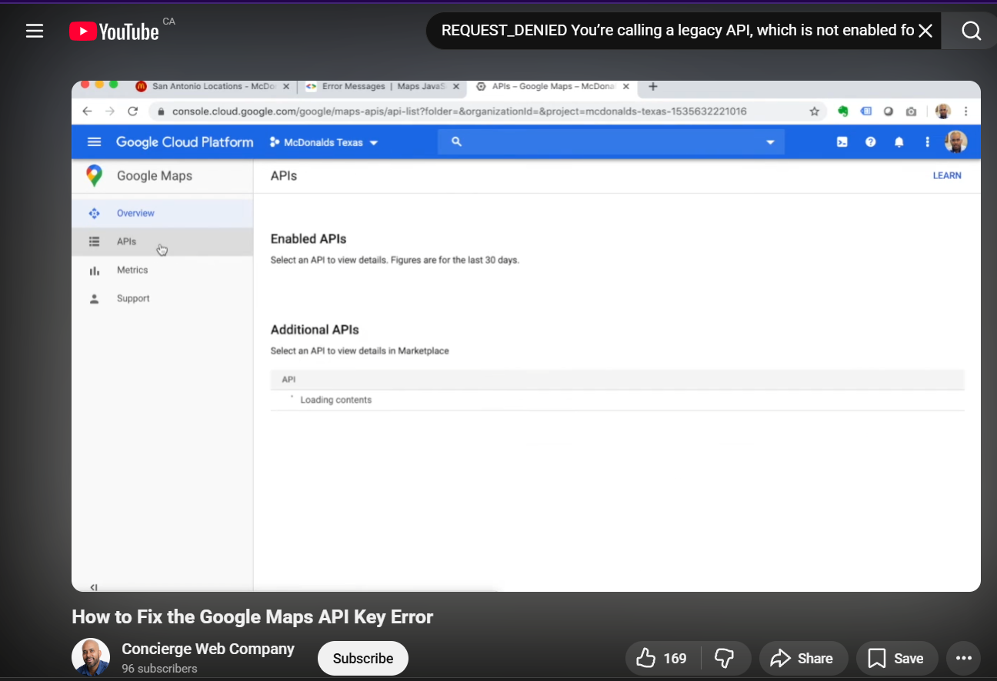
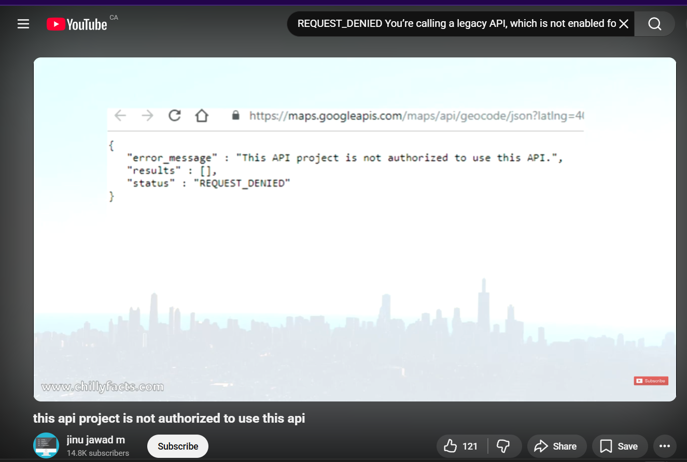

AWS Cognito Issue:
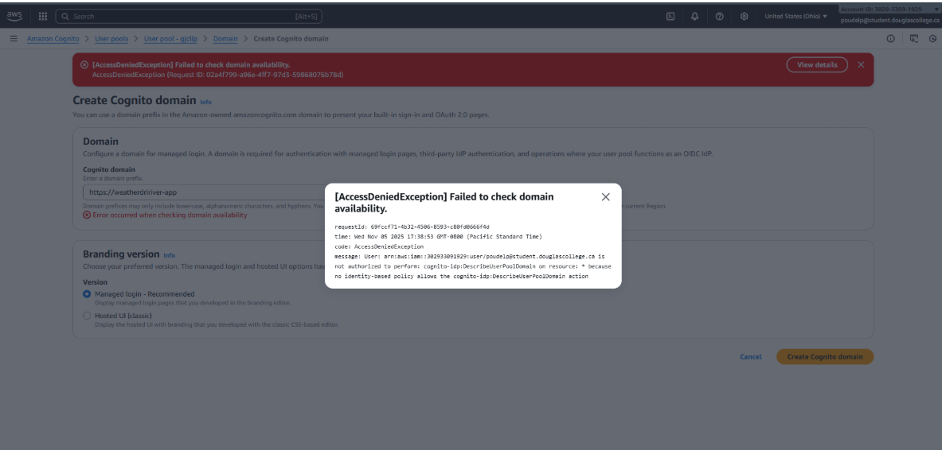
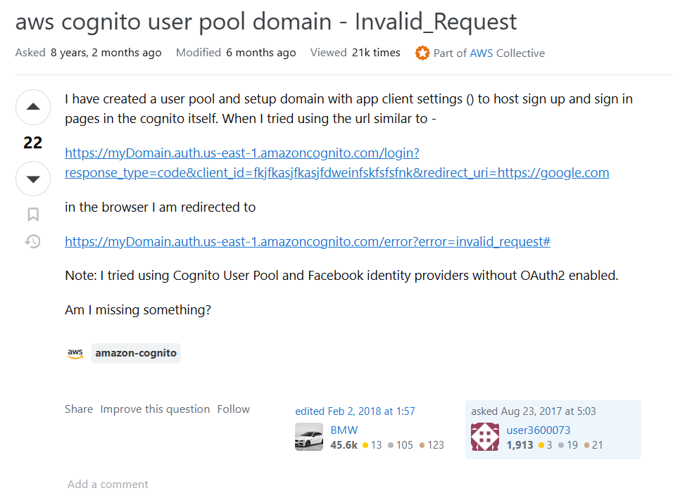
Some Stackoverflow links:
https://stackoverflow.com/questions/49979314/invalid-request-error-on-aws-cognito-custom-ui-page
https://stackoverflow.com/questions/45830982/aws-cognito-user-pool-domain-invalid-request
https://stackoverflow.com/questions/66798827/how-to-figure-which-is-the-right-cognito-error
https://stackoverflow.com/questions/53450036/customization-of-login-page-cognito/79813058#79813058

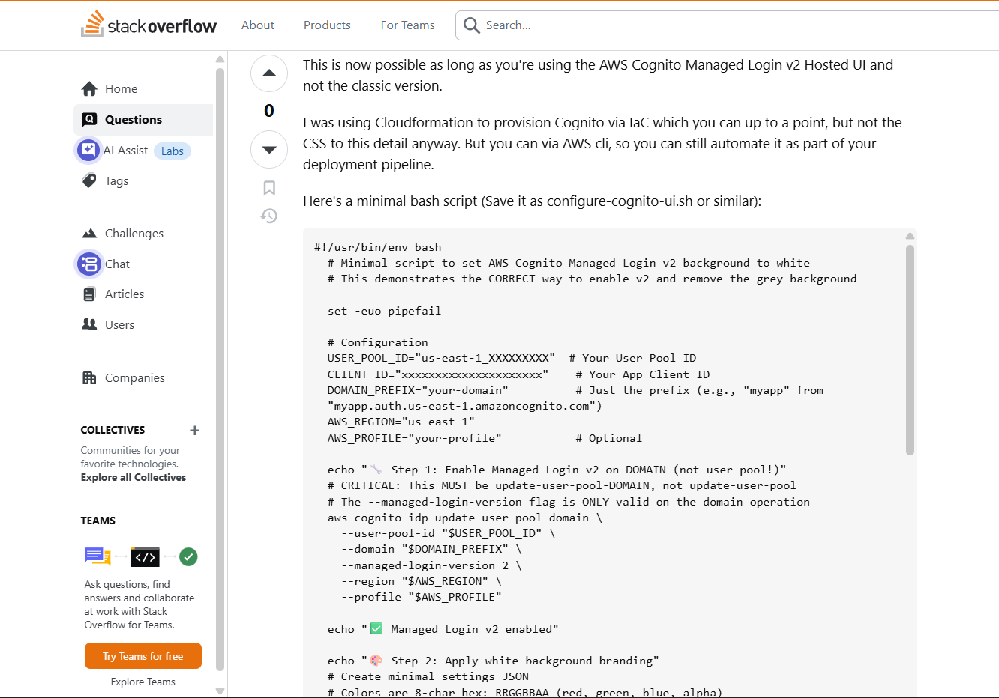
Some Youtube videos considered for AWS Cognito Issues:
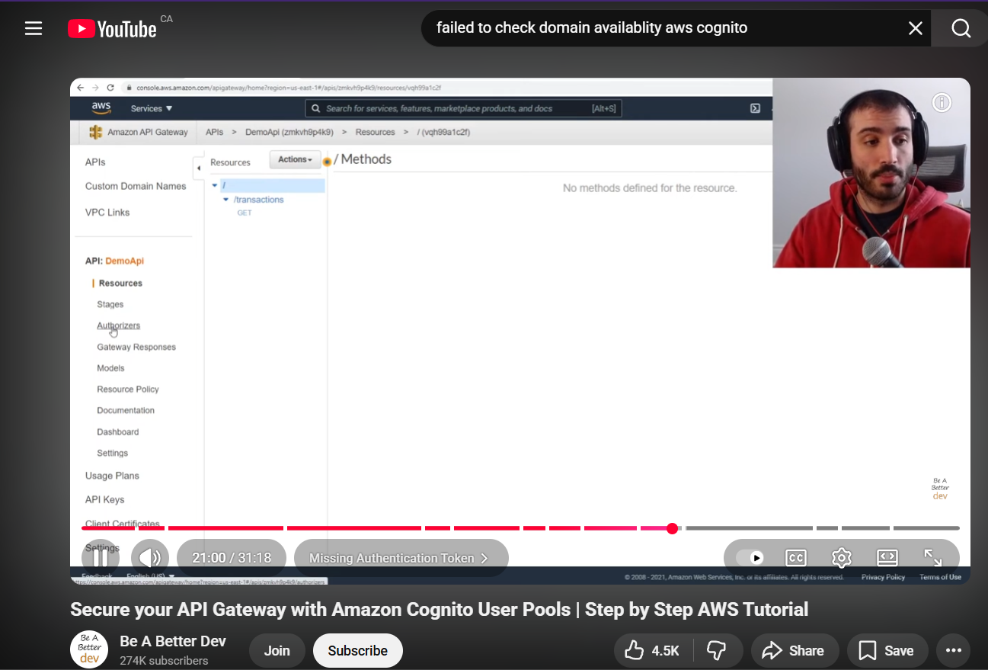
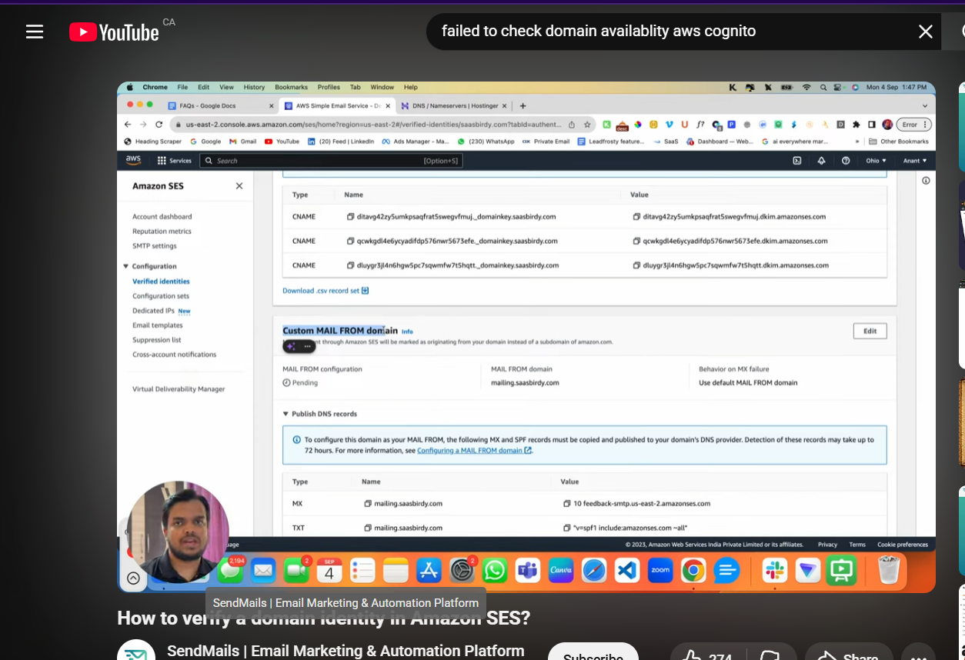
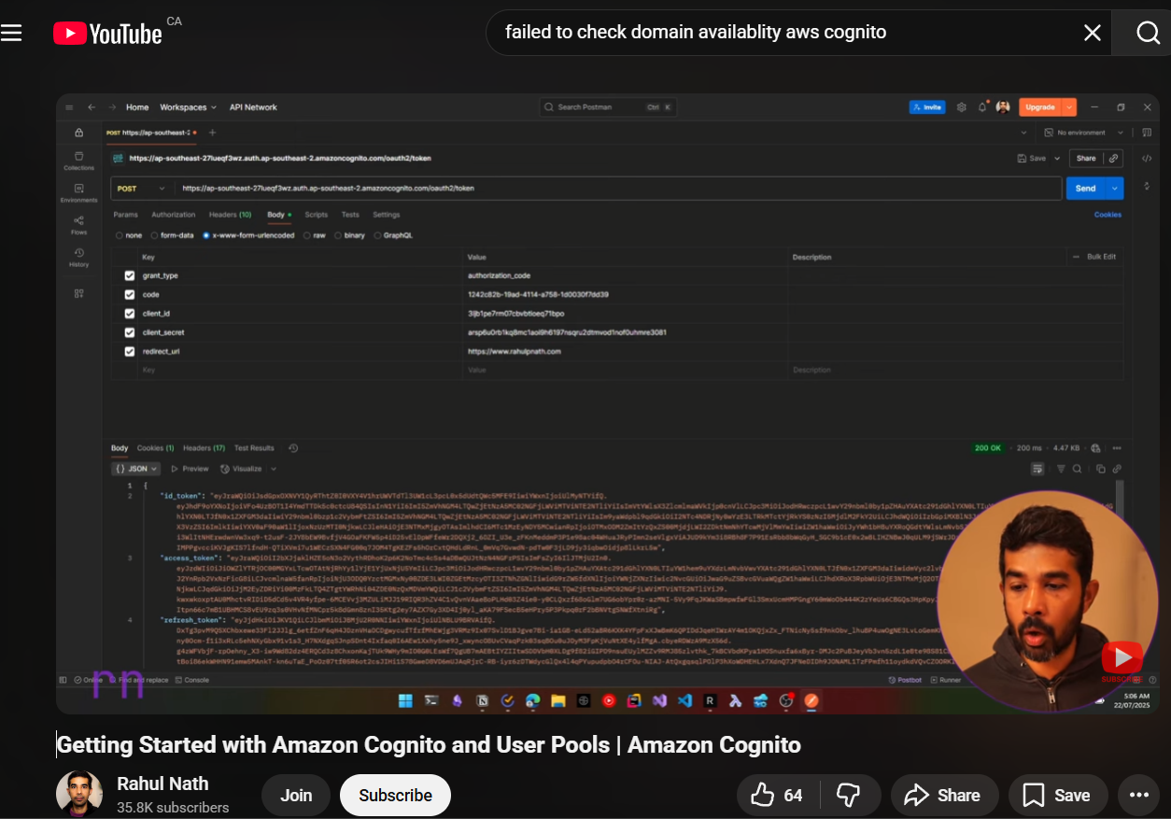

https://www.youtube.com/watch?v=oFSU6rhFETk
https://www.youtube.com/watch?v=4elbue4tXu0
A course from freecodecamp has been taken to re-evaluate the work done.
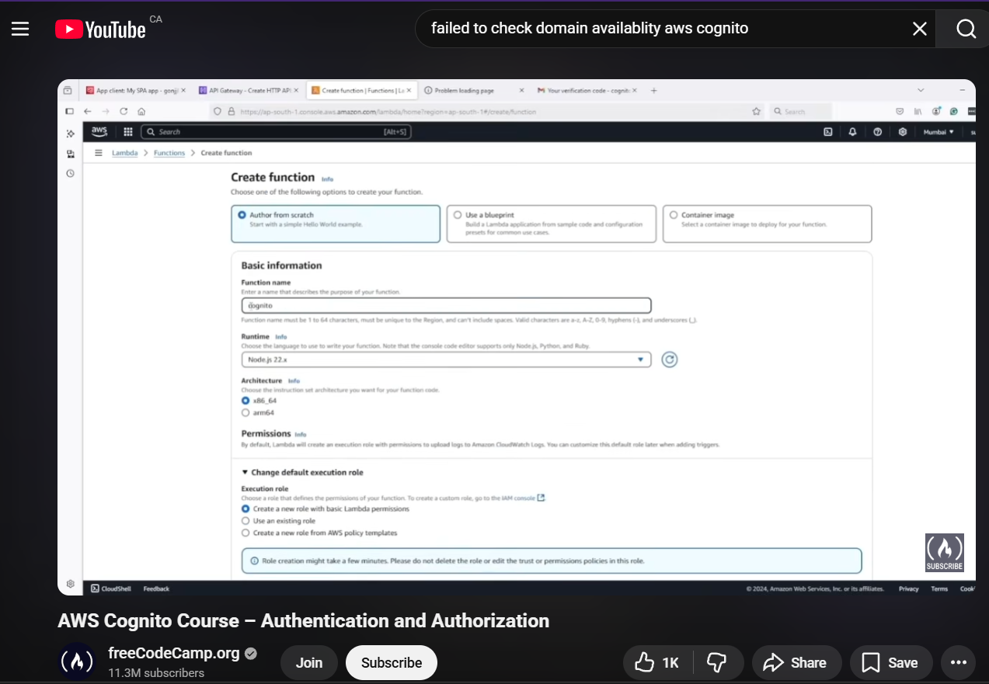
https://www.youtube.com/watch?v=ajExOgOCJXY

